STUDENT CONTACT DETAILS MANAGEMENT SYSTEM

Team members: HARITHA MAHALAKSHMI N

JEEVITHA R

SCREENSHOTS:

Students can add their data.

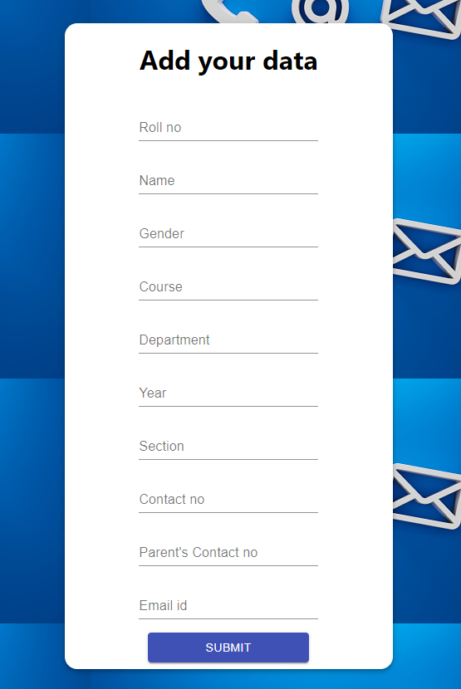

Details entered by the all students displayed here

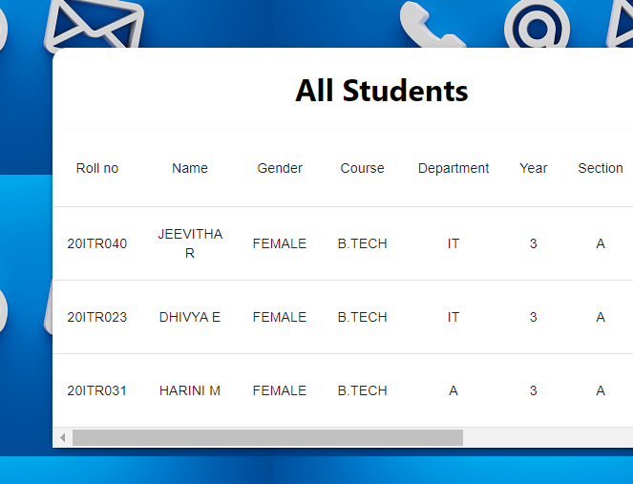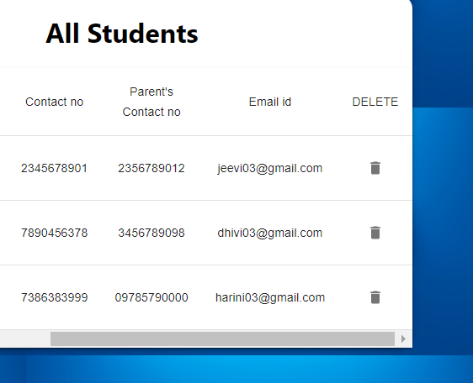

Output:

